
Tertiary Infotech Academy Pte Ltd
UEN: 201200696W
LEARNER GUIDE
For
Decision-Making and Resource Optimization with Linear Programming
TGS Ref No: TGS-2023036656
Conducted by
Tertiary Infotech Academy Pte Ltd
UEN: 201200696W
Version 6.0

DOCUMENT VERSION CONTROL RECORD
Version Number | Effective Date of Release | Summary of Included Changes | Author
5.0 | 10 Jan 2024 | Legacy learner-guide slide deck (153 slides, rasterised tables). | Dr Alfred Ang
6.0 | 28 Aug 2026 | Rebuilt as a single-source Learner Guide with detailed click-by-click Excel Solver, decision-analysis and AHP procedures for eight progressive labs, embedded workbook screenshots, a methods reference and a glossary. | Dr Alfred Ang

TABLE OF CONTENTS
Introduction 4
Course Learning Outcomes 4
Before You Start — Excel & the Solver Add-in 4
Topic 01 — Optimisation and Linear Programming for Resource Management 5
Lab 1 — Formulate a Linear Programming Model 6
Lab 2 — Solve for Maximum Profit with Excel Solver 7
Lab 3 — Sensitivity and Scenario Analysis 9
Topic 02 — Decision Analysis for Resource Usage 11
Lab 4 — Expected Value, EVwPI and EVPI 11
Lab 5 — Risk and Expected Utility 13
Topic 03 — Multi-Criteria Decision Analysis 15
Lab 6 — Weighted Scoring Board (MCDA) 15
Lab 7 — AHP — Criteria Priorities and Consistency 17
Lab 8 — Integrated Resource-Allocation Evaluation & KPIs 19
Methods Reference 21
Exam Preparation 22
Glossary 22

Introduction
This Learner Guide accompanies the WSQ course Decision-Making and Resource Optimization with Linear Programming (TGS-2023036656), conducted by Tertiary Infotech Academy Pte Ltd (UEN 201200696W). It gives detailed, click-by-click instructions for all eight hands-on Microsoft Excel labs, organised by the three learning units: Linear Programming, Decision Analysis and Multi-Criteria Decision Analysis.
Use this guide alongside the trainer slides and the workbooks in the labs/ folder. Every method — the Excel Solver, decision trees, Expected Value, Expected Utility, the scoring board and the Analytic Hierarchy Process — is built and solved in Excel so you can reproduce it on your own resource-management problems.

Course Learning Outcomes
- LO1 — Develop a resource-management strategy and allocation plan using Linear Programming (LP) and the Excel Solver.
- LO2 — Develop a resource-allocation plan and track resource usage using Decision Analysis (Expected Value and Expected Utility).
- LO3 — Evaluate resource-management performance and set KPIs using Multi-Criteria Decision Analysis (scoring board and the Analytic Hierarchy Process).
Underpinning knowledge (tested by the Written Assessment)
- K1 — Resource management, allocation and optimisation tools and techniques.
- K2 — The process to determine resource requirements for the organisation and the business unit.
- K3 — Methods to optimise resource usage.
Abilities (tested by the Practical Performance)
- A1 — Develop resource management and allocation strategies.
- A2 — Develop resource allocation plans to support the achievement of strategies.
- A3 — Determine resource needs to support resource allocation planning.
- A4 — Develop resource allocation plans to support business unit activities.
- A5 — Develop procedures and systems to monitor and evaluate resource usage.
- A6 — Review resource usage to determine sufficiency and optimal utilisation.
- A7 — Propose improvements to optimise resource usage.
- A8 — Review resource-management outcomes to ascertain refinements to the resource-allocation plan.
- A9 — Develop resource-management Key Performance Indicators (KPIs).

Before You Start — Excel & the Solver Add-in
What you need
- Microsoft Excel (Windows or Mac) — the Solver add-in ships with Excel and is free to enable.
- The lab workbooks and sample CSV data from the labs/ folder (download them from the LMS course page).
- About 15 minutes to enable Solver the first time; after that it stays on the Data tab.
Enable the Solver add-in (one time)
- Open the Excel Options dialog — In Excel, click File → Options (on Mac: Tools → Excel Add-ins).
- Go to Add-ins — Select Add-ins in the left pane, then at the bottom set 'Manage: Excel Add-ins' and click Go.
- Tick the Solver Add-in — In the Add-ins dialog, tick 'Solver Add-in' and click OK.
- Confirm it loaded — Open the Data tab — a 'Solver' button now appears in the Analyze group on the far right.
Download the lab material
- Open the LMS portal — Go to https://lms-tms.tertiaryinfotech.com and log in with your registration e-mail.
- Open this course — Select this course and open Course Materials.
- Download the workbooks — Download the lab workbooks and CSV data, and the trainer slides / this guide (PDF).
Conventions used in every lab
- Cell references are written like C4, E6 or $C$4:$D$4 (a $ locks the reference when you copy a formula).
- Yellow cells are the changing cells Solver may vary; shaded result cells hold the objective or the answer.
- Formulas are shown exactly as you type them, e.g. =SUMPRODUCT(C6:D6,C4:D4).
- Each lab has its own folder under labs/ with the workbook, the CSV data and a verification note.

Topic 01 — Optimisation and Linear Programming for Resource Management
LP models · decision variables, objective and constraints · Excel Solver · sensitivity and scenario analysis
Key concepts
- Optimisation frames resource management — Choose the allocation of scarce resources that maximises profit or minimises cost, subject to the limits you actually face.
- A Linear Programming model has three parts — Decision variables (what you choose), an objective function (what you optimise), and constraints (the resource limits).
- Excel Solver solves the model — The Simplex LP engine searches the feasible region for the corner point that optimises the objective — no manual algebra.
- Sensitivity analysis makes the plan robust — Shadow prices value each resource; objective and right-hand-side ranges show how far data can move before the plan changes.
- Diagnostics keep you honest — Infeasible, unbounded, degenerate and multiple-optima outcomes each have a cause and a fix you can recognise.

Lab 1 — Formulate a Linear Programming Model
Maps to: A1, A3, K1 — develop an allocation strategy by translating a resource problem into an LP model.
Goal: Turn Lucy's Cupcakes resource problem into a Linear Programming model: name the decision variables, write the profit objective, and express every resource limit as a linear constraint.
What you'll build
A complete LP model (objective + four constraints) laid out on a formula-driven Excel worksheet, ready to solve. (Tools: Microsoft Excel, lab CSV data.) Workbook: labs/lab-01-lp-formulation/lucys_cupcakes.xlsx · Data: labs/lab-01-lp-formulation/data/lucys_cupcakes.csv
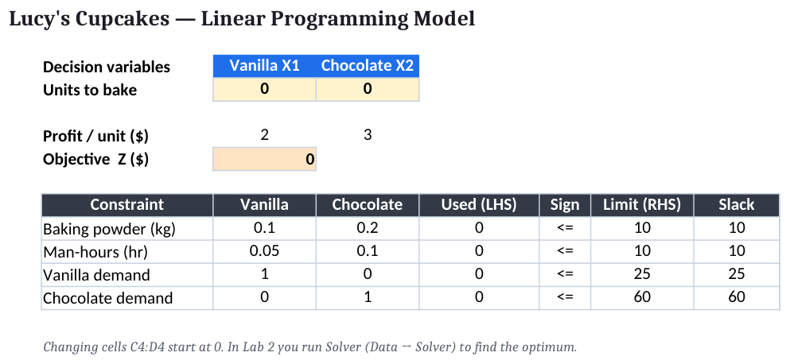
Lab 1 — Formulate a Linear Programming Model: the completed Excel workbook
Step-by-step (click-by-click)
- Open the starter workbook — Open labs/lab-01-lp-formulation/lucys_cupcakes.xlsx and read the Problem sheet — 2 products, baking powder 10 kg, 10 man-hours, demand caps 25 and 60.
- Define the decision variables — In cells C4 and D4 (the yellow changing cells) enter a trial value of 0 for Vanilla (X1) and Chocolate (X2). These are what Solver will choose.
- Enter the profit coefficients — In C6 type 2 (profit per vanilla) and in D6 type 3 (profit per chocolate).
- Build the objective cell — In E6 enter =SUMPRODUCT(C6:D6,C4:D4). This computes total profit Z = 2·X1 + 3·X2.
- Enter the baking-powder constraint — Row 9: C9=0.1, D9=0.2; in E9 enter =SUMPRODUCT(C9:D9,$C$4:$D$4); G9=10 (kg available).
- Enter the man-hours constraint — Row 10: C10=0.05, D10=0.1; E10 =SUMPRODUCT(C10:D10,$C$4:$D$4); G10=10 (hours).
- Enter the demand constraints — Row 11 (Vanilla): C11=1, D11=0, E11 =SUMPRODUCT(...), G11=25. Row 12 (Chocolate): C12=0, D12=1, G12=60.
- Add a slack column — In H9:H12 enter =G9-E9 (drag down). Slack = limit − used; it shows spare capacity once the model is solved.
Expected outputs
- Objective form: Max Z = 2·X1 + 3·X2
- Baking powder: 0.1·X1 + 0.2·X2 ≤ 10
- Man-hours: 0.05·X1 + 0.1·X2 ≤ 10
- Demand: X1 ≤ 25, X2 ≤ 60, X1,X2 ≥ 0
✅ Test it: The worksheet shows a single objective cell (E6) and four constraint LHS cells (E9:E12), each a SUMPRODUCT of coefficients and the changing cells. With X1=X2=0 the objective reads 0 and every constraint LHS reads 0.
If it doesn't work — diagnostics
- Objective is a fixed number, not a formula → You typed the profit instead of =SUMPRODUCT(...). Solver can only optimise a cell that depends on the changing cells.
- Constraint uses absolute vs relative refs wrongly → Lock the changing cells with $C$4:$D$4 so the formula copies down correctly.
- A resource limit is on the wrong side → The limit (RHS) is a constant in column G; the used amount (LHS) is the SUMPRODUCT in column E. Do not swap them.

Lab 2 — Solve for Maximum Profit with Excel Solver
Maps to: A2, K1 — develop an allocation plan that maximises profit using the Excel Solver.
Goal: Run the Simplex LP engine in Excel Solver on the Lucy's Cupcakes model to find the profit-maximising production plan and produce the Answer Report.
What you'll build
The optimal plan X1=25, X2=37.5 giving Z=$162.50, plus a Solver Answer Report showing binding and non-binding constraints. (Tools: Microsoft Excel, Solver add-in.) Workbook: labs/lab-02-solver-maxprofit/solver_maxprofit.xlsx · Data: labs/lab-02-solver-maxprofit/data/solver_targets.csv
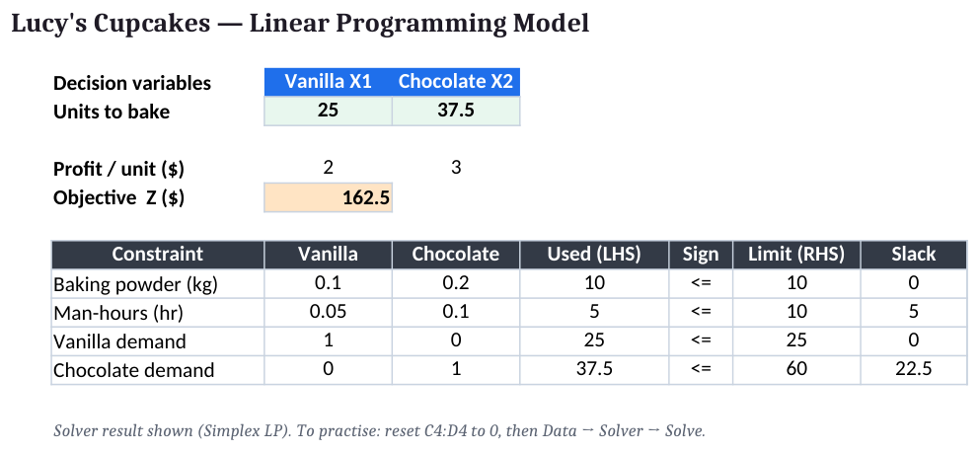
Lab 2 — Solve for Maximum Profit with Excel Solver: the completed Excel workbook
Step-by-step (click-by-click)
- Load the Solver add-in — File → Options → Add-ins → Manage: Excel Add-ins → Go → tick 'Solver Add-in' → OK. Solver now appears on the Data tab.
- Open Solver — Data tab → Solver.
- Set the objective — Set Objective: $E$6. To: Max.
- Set the changing cells — By Changing Variable Cells: $C$4:$D$4.
- Add the resource constraints — Add → Cell Reference $E$9:$E$10 → <= → Constraint $G$9:$G$10 (baking powder and man-hours). OK.
- Add the demand constraints — Add → $E$11:$E$12 → <= → $G$11:$G$12 (vanilla and chocolate demand caps). OK.
- Force non-negativity — Tick 'Make Unconstrained Variables Non-Negative' — this is the X1,X2 ≥ 0 constraint.
- Choose Simplex LP — Select a Solving Method: Simplex LP (the model is linear).
- Solve — Click Solve. When 'Solver found a solution' appears, select Reports → Answer, then Keep Solver Solution → OK.
- Read the result — C4 shows 25 (vanilla), D4 shows 37.5 (chocolate), E6 shows 162.5 — the maximum profit.
Expected outputs
- X1 (Vanilla): 25 units
- X2 (Chocolate): 37.5 units
- Max profit Z: $162.50
- Binding: Baking powder, Vanilla demand
- Not binding: Man-hours (slack 5), Chocolate demand (slack 22.5)
✅ Test it: The changing cells read X1=25 and X2=37.5, the objective E6 reads 162.5, and the Answer Report lists baking powder and vanilla-demand as Binding (slack 0) while man-hours and chocolate-demand are Not Binding (slack 5 and 22.5).
If it doesn't work — diagnostics
- Solver is not on the Data tab → The add-in is not loaded — repeat the Add-ins step and tick 'Solver Add-in'.
- 'Solver could not find a feasible solution' → A constraint is impossible or a sign is reversed. Check every LHS ≤ RHS and that the RHS limits are positive.
- 'The Objective Cell values do not converge' (unbounded) → A binding resource constraint is missing, so profit can grow without limit. Add the omitted constraint.
- Fractional answer 37.5 looks wrong → LP allows divisible outputs; 37.5 batches is valid here. Add an integer constraint only if the product is truly indivisible.

Lab 3 — Sensitivity and Scenario Analysis
Maps to: A2, A3, A6 — review sufficiency and optimal utilisation using the Sensitivity Report and what-if scenarios.
Goal: Read the Solver Sensitivity Report to value each resource (shadow prices) and find the ranges over which the plan holds, then run what-if scenarios that change a resource limit or a profit rate.
What you'll build
A Sensitivity Report with shadow prices and allowable ranges, plus a small scenario table comparing profit as baking powder and profit rates change. (Tools: Microsoft Excel, Solver add-in, Scenario Manager / Data Table.) Workbook: labs/lab-03-sensitivity-scenario/sensitivity_scenario.xlsx · Data: labs/lab-03-sensitivity-scenario/data/scenarios.csv
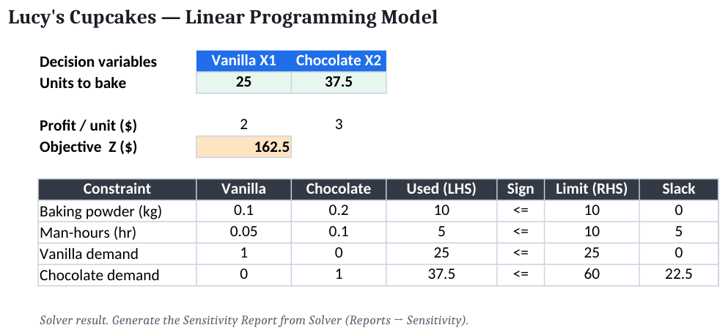
Lab 3 — Sensitivity and Scenario Analysis: the completed Excel workbook
Step-by-step (click-by-click)
- Re-run Solver with the Sensitivity Report — Data → Solver → Solve → in Reports select both Answer and Sensitivity → OK. A new 'Sensitivity Report' sheet is created.
- Read the shadow prices — In the Constraints table, the Shadow Price column values the binding resources: baking powder ≈ $15 per kg; man-hours = $0 (spare capacity).
- Read the RHS ranges — Allowable Increase / Decrease show how far each limit can move before the shadow price changes — the range over which the price is valid.
- Read the objective ranges — In the Variable Cells table, Allowable Increase / Decrease on the profit coefficients show how much a price can change before the optimal plan changes.
- Set up a scenario — Copy the baking-powder limit G9 to a scenario area. Using Scenario Manager (Data → What-If Analysis → Scenario Manager) add scenarios: G9 = 8, 10, 12 kg.
- Compare scenarios — Show each scenario and record the new optimal profit from E6 to see the value of extra baking powder.
- Stress a profit rate — Change the chocolate profit D6 from 3 to 2.5 and re-solve; note whether the optimal mix changes.
- Write the recommendation — Recommend acquiring the binding resource with the highest shadow price, but only up to its allowable increase.
Expected outputs
- Baking powder shadow price: ≈ $15 / kg (binding)
- Man-hours shadow price: $0 (slack 5 hr)
- +2 kg baking powder: Profit rises ≈ $30 (within range)
- Recommendation: Buy baking powder, not man-hours
✅ Test it: The Sensitivity Report shows baking powder with a positive shadow price and man-hours with a $0 shadow price; increasing baking powder within its allowable increase raises profit by about $15 per kg, and the scenario table shows profit rising as the baking-powder limit increases.
If it doesn't work — diagnostics
- No Sensitivity Report is produced → You must select Simplex LP; the GRG Nonlinear engine gives a different report. Re-solve with Simplex LP.
- All shadow prices are zero → No constraint is binding — the solution is interior or the model is under-constrained. Re-check the resource limits.
- Shadow price used outside its range → A shadow price is only valid within the allowable increase/decrease. Beyond it, re-solve rather than extrapolate.
- Scenario profit does not change → The changed resource was not binding (had slack), so more of it adds no value — spend on the binding resource instead.

Topic 02 — Decision Analysis for Resource Usage
Decision trees · Expected Value (EV, EVwPI, EVPI) · risk and Expected Utility
Key concepts
- Decisions under uncertainty need structure — A decision problem is a set of decisions, uncertain states of nature with probabilities, and a payoff for every combination.
- Decision trees make the structure visible — Square decision nodes branch into your choices; round chance nodes branch into states — you fold back to the best expected payoff.
- Expected Value ranks the alternatives — EV = Σ probability × payoff. The decision with the highest expected payoff is the EV-optimal choice.
- Perfect information has a price — EVPI = EVwPI − EV is the most you should ever pay to remove the uncertainty before deciding.
- Expected Utility captures risk attitude — When outcomes are large or risky, replacing money with utility separates a risk-averse choice from a risk-neutral one.

Lab 4 — Expected Value, EVwPI and EVPI
Maps to: A4, A5, K2 — determine resource needs and monitor usage by ranking options on expected payoff.
Goal: Build a decision table for KAZO's expansion choice, compute the Expected Value of each option, then find the Expected Value with Perfect Information and the Expected Value of Perfect Information.
What you'll build
A formula-driven decision table that ranks three options by EV (best EV=$345k), and computes EVwPI=$365k and EVPI=$20k. (Tools: Microsoft Excel.) Workbook: labs/lab-04-expected-value/kazo_decision.xlsx · Data: labs/lab-04-expected-value/data/kazo_decision.csv
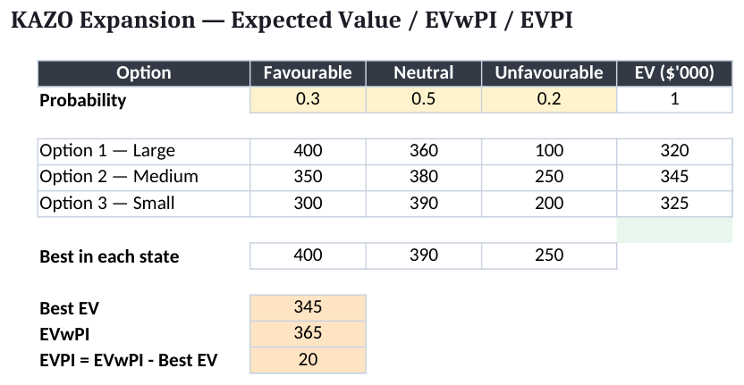
Lab 4 — Expected Value, EVwPI and EVPI: the completed Excel workbook
Step-by-step (click-by-click)
- Open the workbook — Open labs/lab-04-expected-value/kazo_decision.xlsx → Decision sheet. Rows = Option 1/2/3, columns = Favourable / Neutral / Unfavourable.
- Enter the probabilities — In C4:E4 enter the state probabilities 0.3, 0.5, 0.2. In F4 enter =SUM(C4:E4) and confirm it equals 1.
- Enter the payoffs ($'000) — Option 1 row: 400, 360, 100. Option 2 row: 350, 380, 250. Option 3 row: 300, 390, 200.
- Compute EV for each option — In the EV column enter =SUMPRODUCT($C$4:$E$4,C6:E6) for Option 1 and copy down for Options 2 and 3.
- Identify the best option — Use =MAX(EV range) and =INDEX(...,MATCH(...)) to flag the highest EV — Option 2 at $345k.
- Compute the best payoff per state — In a 'best-in-state' row enter =MAX(C6:C8) for Favourable and copy across for Neutral and Unfavourable → 400, 390, 250.
- Compute EVwPI — EVwPI =SUMPRODUCT(C4:E4, best-in-state row) = 0.3·400 + 0.5·390 + 0.2·250 = 365.
- Compute EVPI — EVPI = EVwPI − best EV = 365 − 345 = 20. This is the most KAZO should pay for perfect market information.
Expected outputs
- EV Option 1: $320k
- EV Option 2: $345k ← choose
- EV Option 3: $325k
- EVwPI: $365k
- EVPI: $20k
✅ Test it: The EV column shows Option 1 = 320, Option 2 = 345, Option 3 = 325; the best-EV flag points to Option 2; EVwPI reads 365 and EVPI reads 20 (all in $'000).
If it doesn't work — diagnostics
- Probabilities do not sum to 1 → F4 must equal 1. A typo in C4:E4 skews every EV. Fix the probabilities first.
- EV uses the wrong probability row → Lock the probability range with $C$4:$E$4 so SUMPRODUCT always multiplies by the correct state probabilities.
- EVPI comes out negative → You subtracted in the wrong order or picked the wrong best EV. EVPI = EVwPI − best EV and is always ≥ 0.
- EVwPI equals the best EV → You averaged option rows instead of taking the best payoff in each state. Use MAX per column for the best-in-state row.

Lab 5 — Risk and Expected Utility
Maps to: A6, K2 — review sufficiency and optimal utilisation when outcomes carry risk.
Goal: Compare two resource-allocation projects with the SAME expected value but different risk, using a utility function to separate the risk-averse choice from a risk-neutral one, and quantify the risk premium.
What you'll build
A utility table showing that with U(x)=√x the safer Project A (certainty equivalent $49.5k) beats the risky Project B ($40.0k) even though both have EV=$50k. (Tools: Microsoft Excel.) Workbook: labs/lab-05-expected-utility/risk_utility.xlsx · Data: labs/lab-05-expected-utility/data/risk_utility.csv
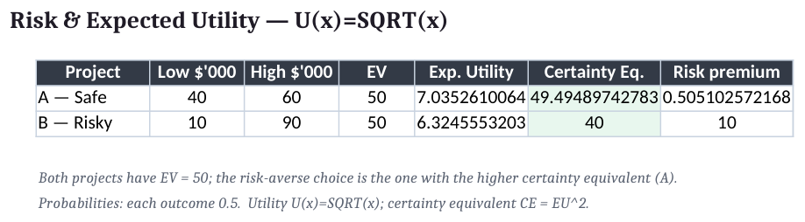
Lab 5 — Risk and Expected Utility: the completed Excel workbook
Step-by-step (click-by-click)
- Open the workbook — Open labs/lab-05-expected-utility/risk_utility.xlsx → Utility sheet. Two projects, two equally likely outcomes each (probability 0.5).
- Enter the payoffs ($'000) — Project A: 40 and 60. Project B: 10 and 90. In the probability cells enter 0.5 for each outcome.
- Confirm equal EV — EV_A =SUMPRODUCT(prob,payoff_A)=50; EV_B =SUMPRODUCT(prob,payoff_B)=50. Both projects have the same expected value.
- Add a utility column — For each payoff x compute U=SQRT(x): √40=6.325, √60=7.746, √10=3.162, √90=9.487.
- Compute expected utility — EU_A =SUMPRODUCT(prob,U_A)=7.035; EU_B =SUMPRODUCT(prob,U_B)=6.325.
- Compute certainty equivalents — Invert the utility: CE = EU². CE_A =7.035^2 = 49.5; CE_B = 6.325^2 = 40.0.
- Compute the risk premium — Risk premium = EV − CE. Project A ≈ 0.5; Project B = 10.0 — the risky project's premium is far larger.
- Recommend — A risk-averse manager chooses Project A: same EV, higher certainty equivalent, lower risk premium.
Expected outputs
- EV (both): $50k
- EU Project A: 7.035 → CE $49.5k
- EU Project B: 6.325 → CE $40.0k
- Risk premium B: $10k
- Choice: Project A (risk-averse)
✅ Test it: EV_A = EV_B = 50, but EU_A = 7.035 > EU_B = 6.325 and CE_A = 49.5 > CE_B = 40.0, so the risk-averse choice is Project A; Project B carries a $10k risk premium versus A's $0.5k.
If it doesn't work — diagnostics
- Both projects tie → You compared EV, not expected utility. With equal EV the tie-break is EU / certainty equivalent, not EV.
- Utility applied to the EV instead of each outcome → Apply U(x) to every outcome first, then average — U(E[x]) ≠ E[U(x)] (that gap is exactly the risk premium).
- Certainty equivalent exceeds EV → For a risk-averse (concave) utility, CE ≤ EV always. A CE above EV means the inverse was applied wrongly.
- Risk-seeking result → √x is concave (risk-averse). A convex utility (e.g. x²) would flip the choice toward the risky project — pick the curve that matches the manager's attitude.

Topic 03 — Multi-Criteria Decision Analysis
Weighted scoring board · Analytic Hierarchy Process · pairwise comparison, consistency and KPIs
Key concepts
- Real decisions weigh many criteria — When cost, quality, risk and fit all matter, a single objective is not enough — you need a multi-criteria method.
- The scoring board is the quick tool — Weight each criterion, rate each option, and rank by the weighted total score = Σ weight × rating.
- AHP adds rigour through pairwise comparison — Compare criteria two at a time on Saaty's 1-9 scale and derive priority weights from the comparison matrix.
- Consistency is checkable — The Consistency Ratio CR = CI/RI tests whether your judgements hang together; CR ≤ 0.10 is acceptable.
- AHP synthesises a defensible ranking and KPIs — Combine criteria priorities with per-criterion scores to rank options, and reuse the weights as resource-management KPIs.

Lab 6 — Weighted Scoring Board (MCDA)
Maps to: A7, K3 — propose improvements by ranking options against several weighted criteria.
Goal: Rank three suppliers against five weighted criteria using a scoring board: weight each criterion, rate each supplier, and compute the weighted total score.
What you'll build
A scoring board that ranks Supplier A (42) above B (41) and C (40), with a sensitivity check on the criterion weights. (Tools: Microsoft Excel.) Workbook: labs/lab-06-scoring-board/supplier_scoring.xlsx · Data: labs/lab-06-scoring-board/data/supplier_scoring.csv
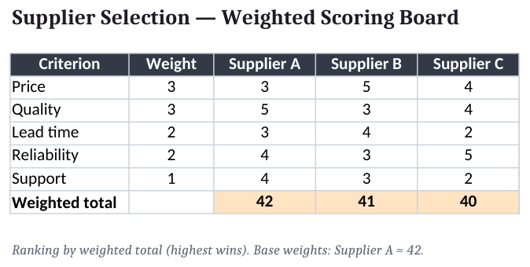
Lab 6 — Weighted Scoring Board (MCDA): the completed Excel workbook
Step-by-step (click-by-click)
- Open the workbook — Open labs/lab-06-scoring-board/supplier_scoring.xlsx → Scoring sheet.
- Enter the criterion weights — In the weight column enter Price 3, Quality 3, Lead time 2, Reliability 2, Support 1.
- Rate each supplier — Score 1 (poor) to 5 (excellent). Supplier A: 3,5,3,4,4. Supplier B: 5,3,4,3,3. Supplier C: 4,4,2,5,2.
- Compute the weighted total — Under each supplier enter =SUMPRODUCT($weights, ratings). A=42, B=41, C=40.
- Rank the options — Use =RANK or sort by total score. Supplier A ranks first.
- Run a weight sensitivity check — Raise the Price weight from 3 to 5 and watch the totals: the price-strong Supplier B can overtake A — showing how weight choices drive the result.
- Record the recommendation — Recommend Supplier A under the base weights, and note the weight at which the decision changes.
Expected outputs
- Supplier A total: 42 ← rank 1
- Supplier B total: 41
- Supplier C total: 40
- Sensitivity: High Price weight favours B
✅ Test it: The weighted totals read Supplier A = 42, Supplier B = 41, Supplier C = 40, so Supplier A ranks first; raising the Price weight shifts the ranking toward Supplier B.
If it doesn't work — diagnostics
- All suppliers score the same → The weights are all equal or all 1. Differentiate the weights to reflect real priorities.
- Ratings on different scales → Keep every criterion on the same 1-5 scale, or normalise first — mixing scales silently biases the total.
- Ranking feels arbitrary → Scores are close (42/41/40). That fragility is exactly why AHP's pairwise weighting is used next.
- A 'lower is better' criterion inflates the score → Reverse the scale for cost-type criteria (5 = cheapest) or the total rewards the wrong option.

Lab 7 — AHP — Criteria Priorities and Consistency
Maps to: A8, K3 — refine the plan by deriving defensible criteria weights and checking their consistency.
Goal: Use the Analytic Hierarchy Process to weight four resource-management criteria by pairwise comparison on Saaty's 1-9 scale, derive priority weights, and verify judgement consistency with the Consistency Ratio.
What you'll build
Criteria priorities Cost 0.398, Quality 0.085, Delivery 0.218, Flexibility 0.299, with lambda_max=4.185, CI=0.062 and CR=0.068 (consistent). (Tools: Microsoft Excel.) Workbook: labs/lab-07-ahp-consistency/ahp_criteria.xlsx · Data: labs/lab-07-ahp-consistency/data/ahp_criteria.csv
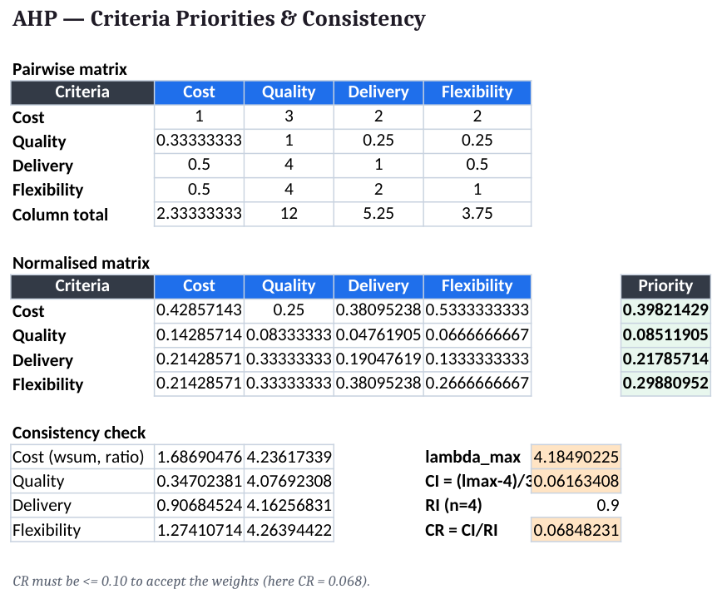
Lab 7 — AHP — Criteria Priorities and Consistency: the completed Excel workbook
Step-by-step (click-by-click)
- Open the workbook — Open labs/lab-07-ahp-consistency/ahp_criteria.xlsx → Pairwise sheet. Criteria order: Cost, Quality, Delivery, Flexibility.
- Enter the pairwise judgements — Upper triangle: Cost vs Quality=3, Cost vs Delivery=2, Cost vs Flexibility=2, Quality vs Delivery=1/4, Quality vs Flexibility=1/4, Delivery vs Flexibility=1/2. Diagonal = 1.
- Fill the reciprocals — Lower triangle = 1/upper (e.g. Quality vs Cost =1/3). Use =1/cell so the matrix stays reciprocal.
- Sum each column — In the totals row enter =SUM(column). Totals: 2.333, 12, 5.25, 3.75.
- Normalise the matrix — In a second block divide each cell by its column total (=cell/column_total).
- Derive the priority vector — Priority =AVERAGE(normalised row): Cost 0.398, Quality 0.085, Delivery 0.218, Flexibility 0.299 (they sum to 1).
- Compute the weighted-sum vector — Multiply the ORIGINAL matrix by the priority vector (=MMULT) to get the weighted sum for each criterion.
- Compute lambda_max — Divide each weighted-sum entry by its priority and average: lambda_max = 4.185.
- Compute CI and CR — CI = (lambda_max − n)/(n − 1) = (4.185 − 4)/3 = 0.062. With RI(4)=0.90, CR = CI/RI = 0.068.
- Accept or revise — CR = 0.068 ≤ 0.10, so the judgements are consistent and the weights are accepted.
Expected outputs
- Priority — Cost: 0.398
- Priority — Quality: 0.085
- Priority — Delivery: 0.218
- Priority — Flexibility: 0.299
- lambda_max / CI / CR: 4.185 / 0.062 / 0.068 ✓
✅ Test it: The priority vector reads Cost 0.398, Quality 0.085, Delivery 0.218, Flexibility 0.299 (sum 1.000); lambda_max = 4.185, CI = 0.062, CR = 0.068 which is ≤ 0.10, so the criteria weights are consistent and usable.
If it doesn't work — diagnostics
- Priorities do not sum to 1 → You averaged the raw matrix, not the column-normalised matrix. Normalise each column first, then average the rows.
- CR is above 0.10 → Judgements conflict (e.g. A≫B, B≫C but A≈C). Revisit the largest inconsistency and re-judge that pair.
- Matrix is not reciprocal → Every lower-triangle cell must be 1/(its mirror). Enter reciprocals with =1/cell, never by hand.
- Wrong RI used → RI depends on n: RI(3)=0.58, RI(4)=0.90, RI(5)=1.12. Using the wrong RI makes CR meaningless.

Lab 8 — Integrated Resource-Allocation Evaluation & KPIs
Maps to: A8, A9, K3 — synthesise a defensible ranking and convert the criteria weights into resource-management KPIs.
Goal: Combine the AHP criteria priorities with per-criterion scores for three resource-allocation plans to produce a final synthesised ranking, then turn the criteria weights into monitoring KPIs.
What you'll build
A synthesis table ranking Plan P (0.393) above Plan R (0.309) and Plan Q (0.299), plus a KPI dashboard weighting Cost 40%, Flexibility 30%, Delivery 22%, Quality 8%. (Tools: Microsoft Excel.) Workbook: labs/lab-08-integrated-evaluation/integrated_eval.xlsx · Data: labs/lab-08-integrated-evaluation/data/integrated_eval.csv
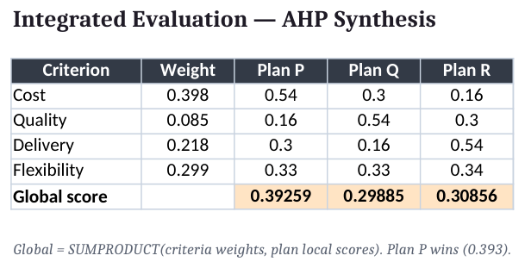
Lab 8 — Integrated Resource-Allocation Evaluation & KPIs: the completed Excel workbook
Step-by-step (click-by-click)
- Open the workbook — Open labs/lab-08-integrated-evaluation/integrated_eval.xlsx → Synthesis sheet.
- Enter the criteria weights — From Lab 7: Cost 0.398, Quality 0.085, Delivery 0.218, Flexibility 0.299 in the weight row.
- Enter the local scores — For each criterion, the normalised scores of Plans P/Q/R (each criterion column sums to 1). Cost: 0.54/0.30/0.16; Quality: 0.16/0.54/0.30; Delivery: 0.30/0.16/0.54; Flexibility: 0.33/0.33/0.34.
- Synthesise each plan — Global score =SUMPRODUCT(criteria weights, plan's local scores): P=0.393, Q=0.299, R=0.309.
- Rank and recommend — Plan P ranks first (0.393). Confirm the three global scores sum to ~1.00.
- Build the KPI dashboard — Convert the criteria priorities to KPI weights (Cost 40%, Flexibility 30%, Delivery 22%, Quality 8%) and list a measurable KPI for each: cost variance, on-time delivery %, utilisation %, defect rate.
- Add a monitor & review note — State the review cadence (e.g. monthly) and the threshold that would trigger a re-allocation — closing the plan-monitor-review loop (A5, A6, A8).
Expected outputs
- Global — Plan P: 0.393 ← rank 1
- Global — Plan R: 0.309
- Global — Plan Q: 0.299
- KPI weights: Cost 40% · Flex 30% · Delivery 22% · Quality 8%
- Loop: Plan → monitor → review → re-allocate
✅ Test it: The synthesis table ranks Plan P = 0.393 first, then Plan R = 0.309 and Plan Q = 0.299 (sum ≈ 1.000); the KPI dashboard carries the AHP-derived weights (Cost 40%, Flexibility 30%, Delivery 22%, Quality 8%) each mapped to a measurable KPI.
If it doesn't work — diagnostics
- Global scores do not sum to ~1 → Either the criteria weights or a local-score column does not sum to 1. Re-normalise before synthesising.
- A plan wins on one criterion but loses overall → That is correct behaviour — synthesis balances all criteria by weight, not a single strength.
- KPI weights ignore AHP → Derive KPI weights from the AHP priorities so monitoring reflects the same priorities used to choose the plan.
- No trigger threshold set → A KPI without a threshold cannot prompt review. Define the value that forces re-allocation (A8).

Methods Reference
Linear Programming (LP)
An LP has decision variables (what you choose), a linear objective (Max Z = c1·X1 + c2·X2 + …) and linear constraints (a1·X1 + a2·X2 + … ≤ b), with X ≥ 0. The Excel Solver's Simplex LP engine searches the corners of the feasible region for the optimum. A binding constraint is fully used (slack 0) and earns a shadow price — the extra profit per one more unit of that resource; a non-binding constraint has slack and a shadow price of 0. Sensitivity analysis reports the ranges over which the plan and the shadow prices stay valid.
Decision Analysis (DA)
A decision problem has decisions, uncertain states of nature with probabilities, and payoffs. Expected Value EV = Σ p·payoff ranks the options; the highest EV is the risk-neutral choice. EVwPI = Σ p·(best payoff in each state) is the value of perfect foresight, and EVPI = EVwPI − best EV is the most you should pay for perfect information. When risk matters, replace money with utility: EU = Σ p·U(payoff); the certainty equivalent CE = U⁻¹(EU) and the risk premium = EV − CE separate a risk-averse choice from a risk-neutral one.
Multi-Criteria Decision Analysis (MCDA) & AHP
A weighted scoring board ranks options by Score = Σ weight·rating. The Analytic Hierarchy Process (AHP) derives the criteria weights from pairwise comparison on Saaty's 1-9 scale: normalise each column of the comparison matrix, average each row to get the priorities, then check consistency with λmax, CI = (λmax − n)/(n − 1) and CR = CI/RI. A CR ≤ 0.10 is acceptable. Synthesis combines the criteria weights with per-criterion scores to rank the options, and the same weights become resource-management KPIs.

Exam Preparation
- First pass: complete all eight labs in Excel, confirming each workbook's result against its Expected Outputs.
- Second pass: rebuild each workbook from a blank sheet until Solver, EV/EVPI and AHP are automatic.
- Know the formulas cold: Max Z with constraints; EV, EVwPI, EVPI; EU, certainty equivalent; Score = Σ w·r; CR = CI/RI.
- Practise reading a Solver Answer Report (binding vs slack) and a Sensitivity Report (shadow prices, ranges).
- Sharpen exam readiness with the Tertiary Infotech practice exam: https://exams.tertiaryinfotech.com
- The Written Assessment (SAQ) tests knowledge K1-K3; the Practical Performance tests abilities A1-A9 in Excel.

Glossary
- Decision variable — A quantity the model chooses (e.g. units of each product), written X1, X2, …
- Objective function — The linear quantity being maximised or minimised, Z = c1·X1 + c2·X2 + …
- Constraint — A linear resource or demand limit, a1·X1 + a2·X2 + … ≤ b.
- Feasible region — The set of allocations satisfying every constraint; its corners are candidate optima.
- Binding constraint — A constraint fully used at the optimum (slack 0) that limits the objective.
- Slack — Spare capacity of a constraint = limit − used; positive slack means non-binding.
- Shadow price — The change in the optimal objective per one extra unit of a binding resource.
- Sensitivity analysis — The ranges over which data can change before the optimal plan or a shadow price changes.
- Expected Value (EV) — EV = Σ probability × payoff; ranks options under uncertainty.
- EVwPI / EVPI — EV with perfect information; EVPI = EVwPI − best EV = the value of perfect information.
- Expected Utility (EU) — EU = Σ p·U(payoff); captures risk attitude via a utility function U(x).
- Certainty equivalent — The guaranteed amount whose utility equals a gamble's expected utility; risk premium = EV − CE.
- Scoring board — A weighted-additive MCDA method: Score = Σ weight × rating.
- AHP — Analytic Hierarchy Process — derives criteria weights from pairwise comparison and checks consistency.
- Consistency Ratio (CR) — CR = CI/RI; judgements are acceptable when CR ≤ 0.10.
- KPI — Key Performance Indicator — a measurable target used to monitor resource usage.

